The EOF: Latest Achievements and Developments

(A paper presented by Mr. Shailesh Burde in the “SteelTech” seminar in Kolkata, on 11th September 2014)

SUMMARY
Developed in Brazil for replacing small open hearth furnaces, the EOF technology has grown and is now striving to occupy its position in the iron and steel world, disputing with the established processes of Electric Arc Furnace (EAF) and the oxygen converter (BOF or LD). Notwithstanding its 24 years of successful operation at the GERDAU Divinopolis plant in Brazil, delivering more than 42 heats per day and about 600.000 t/y liquid steel, and the three efficient units operating in India, the EOF is still little known. This paper endeavors to present the technology with its latest achievements and developments.

Actually, with the three units operating in India since the turn of the century, the EOF experienced a strong evolution and became a reference also in terms of quality steels used for die forging, seamless pipes, cold heading, roller bearings etc, approved by the strictest clients regarding quality control. One of the most remarkable aspects in this regard is the ultralow phos content (< 0,01 %) which may be reached consistently, without impairing the high productivity of the furnace - above 36 heats per day, on 330 working days per year. In times of decreasing quality of iron ores and increasing phos content in hot metal this is an important asset. Slag-free tapping is an additional feature warranting high quality production. Today´s EOF presents itself as a dynamic furnace, with a high level of automation, and combining two usually antagonistic factors: high productivity, essential in any modern iron and steel process; and extraordinary quality, a must in the production of quality steels.

Energy optimization, which bestows the name to the process (“Energy Optimizing Furnace”) allows the EOF to operate with up to 40 % solid charge, pre-heated in the process, in addition to 60 % hot metal. This feature outfits the EOF with extraordinary flexibility regarding charge flexibility. Combined with carbon injection devices, the proportion of DRI in the charge may rise to 25 % and even more - impossible for the BOF and only achievable in the EAF, at a high cost of electric energy. The ongoing evolution of the process, in view of the engineering solutions, warrant growing operational availability and ease of maintenance.

1, INTRODUCTION

Developed in Brazil for replacing small, uneconomic open hearth furnaces about 35 years ago, the Energy Optimizing Furnace or EOF was conceived to utilize the sensible heat of small and medium sized steel converters in an effective way. It is a combined blowing basic oxygen steel making process where a mix of hot metal, scrap and DRI forms the charge. Oxygen is blown through two numbers of submerged tuyeres and one or two numbers of supersonic lances. Post-combustion of the emerging gases above the steel bath is done using four numbers of atmospheric injectors and by air leaking in through the door, thus supplying a part of the heat to the metallic bath and rest for scrap preheating for the subsequent heat. The tap-hole and tilting mechanism is designed for efficient slag-free tapping.

The submerged injected oxygen reacts with the carbon of the bath, generating CO bubbles which promote intense bath agitation, beneficial for reaction kinetics and temperature homogenization. Once the bubbles leave the bath CO is burnt with the oxygen from the atmospheric injectors. The projections of liquid metal caused by the eruption of the CO bubbles promote an extraordinary increase in bath surface, increasing the exposure to oxygen from the supersonic lances and capturing part of the heat generated by after-burning, which is drawn to the bath. The combination of these factors explains the extremely fast decarburizing and temperature rise of the bath, resulting in blowing times similar to that of the BOF. The possibility of tilting of the furnace, allowing continuous extraction of slag through the slag door as well as tapping at the very moment of finishing decarburizing, as well as the instantaneous release of scrap from the scrap preheater, allow tap-to-tap times of less than 30 minutes - an impossibility for the BOF.
Another edge on the BOF is the flexibility of the EOF to operate with up to 40 % scrap in the charge or 15 % DRI. These proportions may be even higher if Carbon injection system is provided.

A further important aspect is the very low investment demanded by the EOF, as compared to the LD converter, while the conversion cost is comparable to LD steelmaking. Actually, the possibility of charging a higher amount of DRI to the EOF reduces its production cost in comparison to the BOF. The investment cost of EOF is lower than that of EAF, considering the high cost of electrical installations.

Hence EOF is the most suitable equipment for converting the liquid hot metal, scrap and DRI to steel, especially for heat sizes of 30 t to 80 t, or annual capacities of 0.3 to 0.8 million tpa.

The following are the main advantages offered by the EOF:
- Flexibility to a great extent, in terms of metallic charge;
- High productivity and furnace availability;
- Steel has very good metallurgical properties;
- Low tramp elements;
- Low inclusions due to continuous flushing of slag during blowing and slag free tapping;
- Electric energy consumption is required only for the auxiliaries;
- Fast bottom exchange (in less than 6 hours),
- Constructive features of the furnace allow quick and efficient charging of hot metal and solid charge, as well as fast and precise tapping.
- Very low noise level
- Low investment and operating cost

Figure 1 presents the main features of the equipment:

Figure 2 is a 3D presentation of the EOF. Design in 3D is the most updated engineering tool, which allows to practically avoid interferences in the detail engineering, fabrication and erection stages, eliminating rework and corrections.

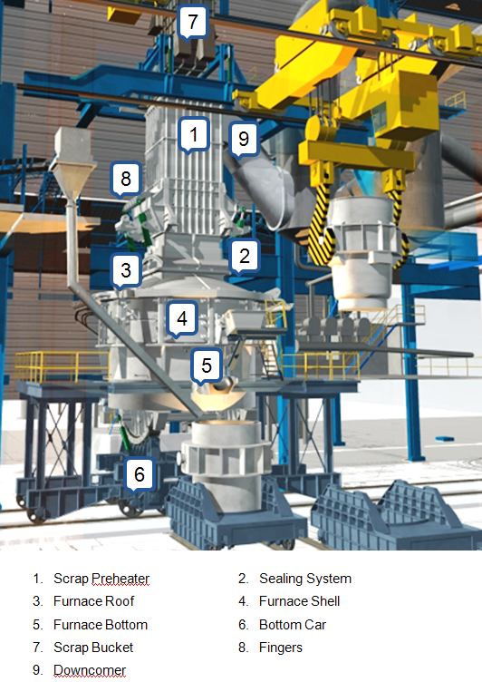

Fig. 1 - Main features of the EOF

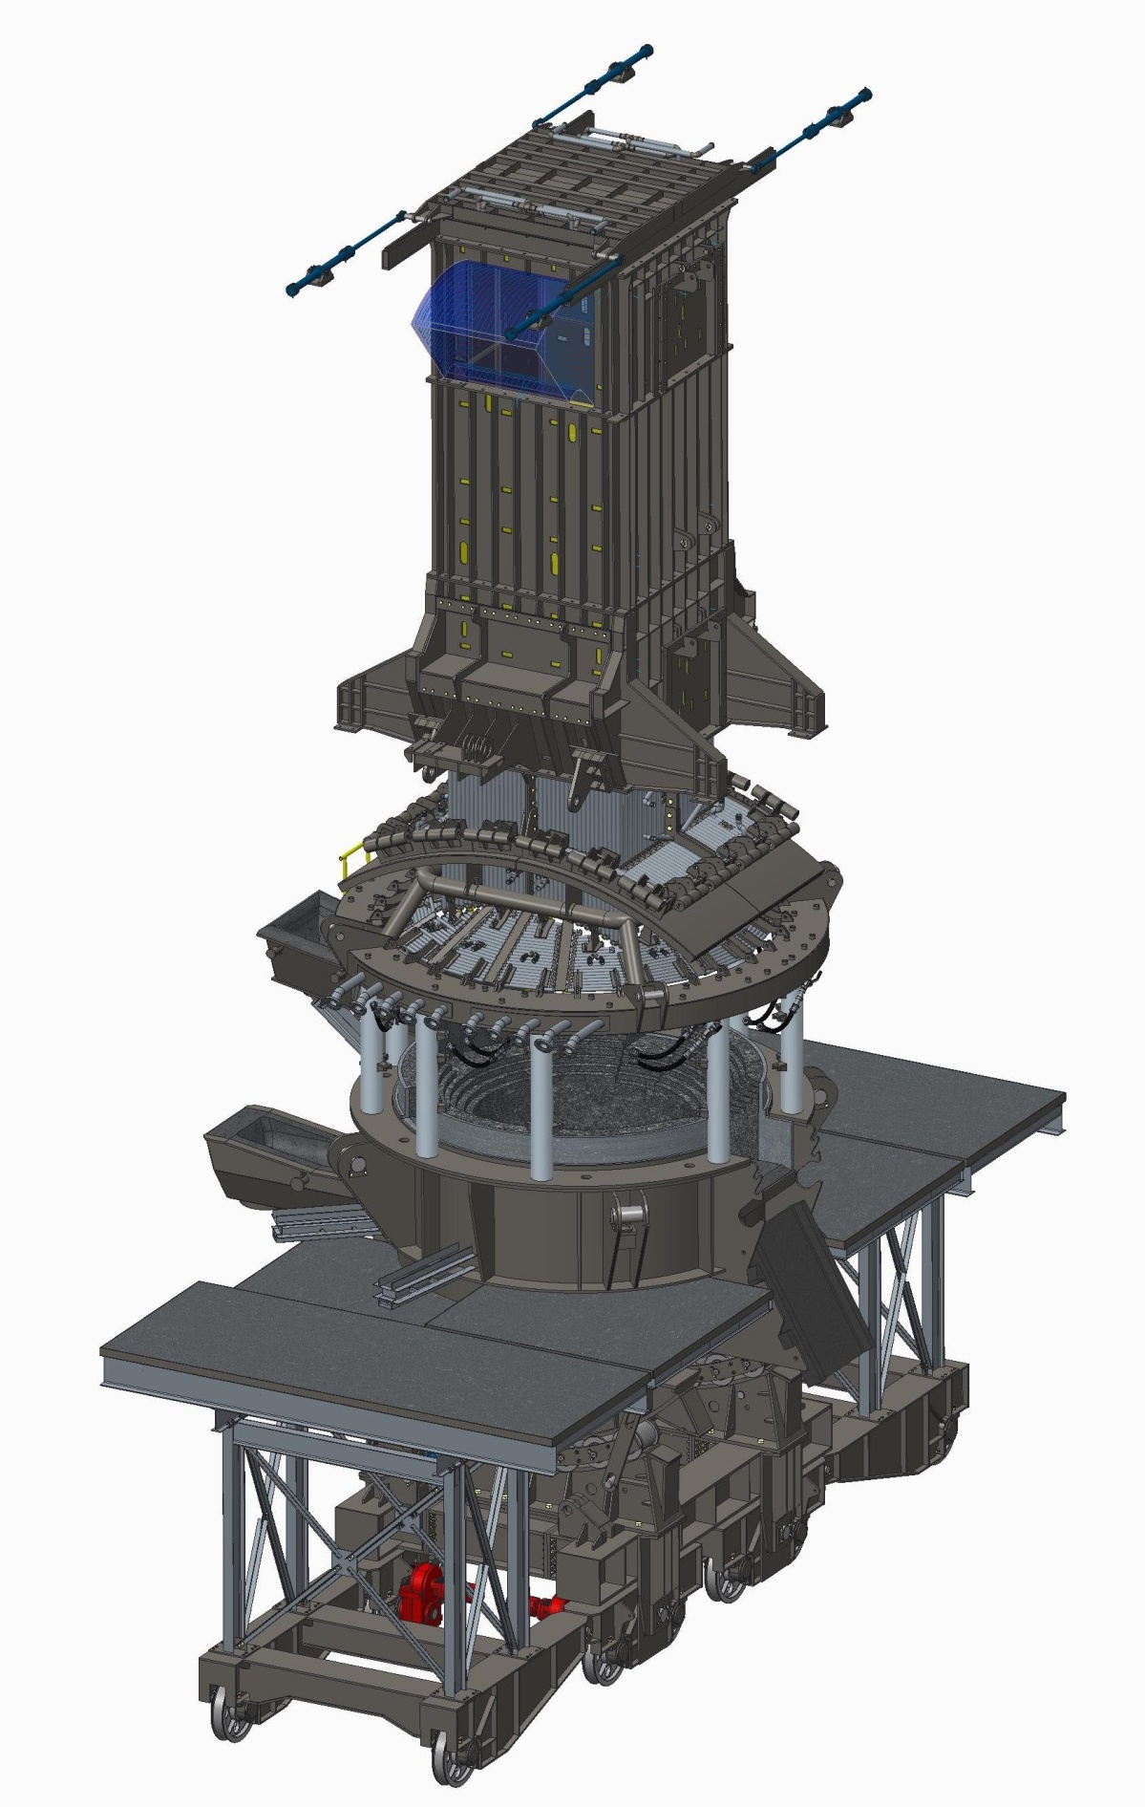

Fig. 2 - A 3D picture of the EOF
2. RECENT PERFORMANCE DATA

Table 1 presents the main operating figures of the EOFs in operation, in Brazil and in India. Figures are averages for the year 2013.

Item |  | Unit | GERDAU | Hospet Steels | JSW – Salem
Rated capacity (Liquid Steel) |  | t | 43,5 | 52 | 45 | 65
 | Hot Metal | % | 68 | 80.5 | 85 | 85
Average charge | Scrap / Pig Iron |  | 18 | 12 | 15 | 15
 | DRI |  | 14 | 7.5 | - | -
Rated capacity |  | ktpa | 570 | 600 | 450 | 650
Production 2013 (Finish Steel) |  | kt | 538 | 504.6 | 370 | 440
Kind of steel |  |  | Rebar | Quality | Rebar & Quality | Quality
Average heats per day (365d/y) |  | h/d | 36,1 | 27.85 | 25 | 24
Oxygen consumption |  | Nm³/t LS | 61 | 54 | 57 | 60
Refractory  consumption | Bricks | kg/t LS | 1,60 | 3.0 | 2.2 | 2.6
 | Gunning Mass |  | 3,68 ⁽²⁾ | 5.5 | 3.6 | 4.0
 | Total |  | 5,28 | 8.5 | 5.8 | 6.6
Electric energy consumption ⁽¹⁾ |  | kWh/t | 45 | 25 | 40 | 44
Average heats per campaign |  | # | 1.036⁽³⁾ | 650 | 850 | 800
- EOF proper (incl. Gas Cleaning, Cooling Water Systems, Alloy Addition, Overhead Cranes)
- Includes launder repairs
- Result of the improvement in tuyere design

Table 1 - EOF operating figures - 2013 averages.

3. BENCH MARK RESULTS

  - Heats per shift: 16 heats tapped in a shift at Hospet Steels Ltd, Karnataka, India.
  - Heats per day: 42 heats tapped in a day at Hospet Steels Ltd, Karnataka, India.
48 heats tapped in a day at GERDAU Divinopolis, Brazil
  - Heats per year: 13.338 heats tapped in a year (2005) at GERDAU Divinópolis, Brazil.
  - Heats per campaign: 1.314, at GERDAU Divinopolis (Campaign Nr. 199 - July 2008) a
result of the improvement in tuyere design.
  - Electrical Energy: 22 units per Ton
  - Phosphorous levels: 0.01 %

4. DESIGN IMPROVEMENTS
- Supersonic lance: Optimum Injection speeds and Lance position for effective results.
- Supersonic lance: Movement by hydraulic cylinder.
- SPH Lower piece water cooled panels: Tubular construction replacing plate construction for longer life.
- Gas Cleaning System (Wet): Stainless Steel construction for better results.Suitable MOC of wetted parts of wet GCP to increase their life. Improved Venturi design.
- Improved cradle design for smooth quick tilt-back.
- Suitability to charge DRI through weigh-feeders.
- Introduction of Coal injection, which will allow a higher proportion of DRI in the charge.
- Introduction of Lime Injection for better assimilation and reduce slag quantity.
- WHRS to utilize waste heat incase SPH is not opted.
- Tuyere design optimized for longer life of refractory.

5. ECONOMICAL CONSIDERATIONS

5.1 Considerations on Operating Cost (opex)
- High productivity optimizes fixed cost
- Low energy consumption
- Low cost of operating consumables
- Low maintenance cost
- Waste heat recovery options

5.2 Considerations on Capital expenditure (capex)
- Optimally sized to reduce the construction and equipment cost
- High productivity in terms of number of heats reduces heat size, hence all equipment and construction cost

5.3 Operating Cost Comparison between EOF - BOF – EAF done by Gerdau Group - Brazil
Table 2 presents the Operating Cost Index, in %, of the EOF (GERDAU Divinopolis), BOF (GERDAU Barão de Cocais) and the best performing EAF of the GERDAU Group in Brazil (excluding raw materials).

Year | EOF | BOF | Best EAF
2001 | 100,0 | 105,8 | 124,7
2002 | 100,0 | 121,5 | 129,9
2003 | 100,0 | 107,2 | 131,9
2004 | 100,0 | 105,1 | 143,7
2005 | 100,0 | 105,1 | 142,9
2006 | 100,0 | 100,3 | 139,1
Avge. | 100,0 | 108,0 | 135,1

Table 2 - Comparison between EOF-BOF-EAF of plants of a same group

Remarks:
(i) It may be observed that during the period covered by this survey, total operating cost (including maintenance) of the BOF was 8 % higher than that of the EOF, while the cost of EAFs was much higher - of course compensated by the lower raw material (scrap) cost.
(ii) The Divinopolis EOF is a 43,5 t unit (originally 35 t), while the Barão de Cocais BOF is a 35 t unit (originally 28 t). Both operate with hot metal from charcoal blast furnaces, while the BOF charges on average 16 % scrap, the EOF averages 36 % scrap.

6. CONCLUSIONS

EOF is proving itself to be the most suitable option for production capacities up to 0.8 mtpa for converting hot metal and varying proportions of scrap and DRI. The quality and productivity levels have been appreciable. Operation and maintenance is much easier than in case of Converter or EAF.
Today the EOF is a proven technology, competing with the classical steel melting processe, with the advantage of producing the most critical quality steels as a routine. Low investment cost (capex) and low operating cost (opex), combined with great flexibility regarding charge mix and low demand of electric energy render the EOF most attractive for any new steel meltshop. This is especially true in areas where electric energy is scarce and expensive, and scrap is not available - conditions which prevail in India these days.
An integrated Mini Steel Plant bsed on mini blast furnaces and an EOF, supported by ladle furnace and continuous casting machine, presents the following advantages:
- It does not depend on availability of a strong electric energy grid
- It presents high yield and productivity
- It demands less capital investment than a BOF plant of same capacity
- It presents a lower operating cost than a plant based on any other technology
- Environmental impact is lower than that of any other melt shop, due to lower noise level and lower emissions
- It warrants steel with highest purity.

Though the number of installations are still few, the coming years will see many installations coming up with new improvements making it an even better option.

